
NEWSLETTER
THE COMMON GROUND
Policy, Equity, and the Future of Social Cohesion
1. THE BIG PICTURE: WHY SOCIAL COHESION MATTERS NOW
Affirmative action is rarely just about numbers, quotas, or admissions statistics. At its core, it is a tool that directly shapes how different groups in society perceive, trust, and interact with one another. When equity policies are misunderstood, friction builds; when they are designed thoughtfully, they build bridges.
This edition explores the central question of my capstone research: How do targeted affirmative action policies actually impact social cohesion, intergroup trust, and shared civic identity?


2. THE CORE ARGUMENT: BEYOND REDISTRIBUTION
Traditional debates often treat affirmative action purely as a mechanism for economic or educational redistribution. However, the data points to a deeper human outcome: social cohesion.
Here are three key takeaways from the research:
- Contact Theory in Action: Bringing diverse groups into shared institutional spaces creates meaningful intergroup contact, which actively reduces bias over time.
- Perceptions of Fairness: Social cohesion thrives when people believe the system offers genuine opportunity. Clarifying how policy operates builds structural trust.
- Long-Term Civic Stability: Diverse leadership pipelines foster broader trust in public institutions, benefiting society as a whole rather than just specific groups.
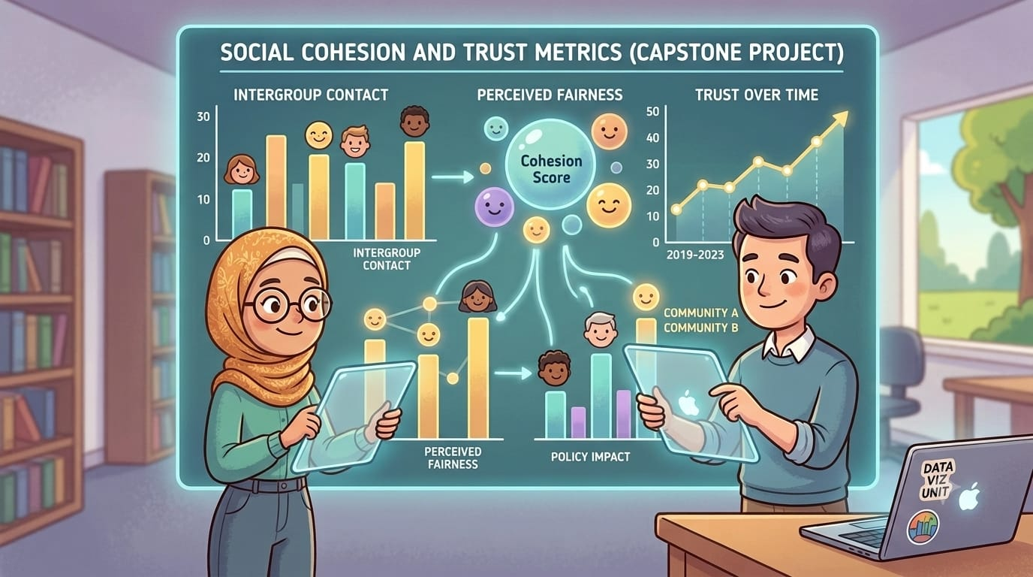

3. MYTH VS. REALITY: ADDRESSING THE FRICTION
MYTH: Affirmative action inherently divides communities and reduces trust between groups.
REALITY: My research demonstrates that perceived tension often stems from miscommunication around how policies function. When policy frameworks are transparent, objective, and paired with strong integration programs, intergroup trust and cooperation actually increase over time.

4. CASE IN POINT: POLICY IN PRACTICE
Consider the impact of institutional integration. In environments where affirmative action policies were paired with structured intergroup dialogue programs, students and employees reported a significant increase in cross-group empathy and shared identity.
Inclusion isn’t just about who gets through the door—it’s about how institutions build community once everyone is inside.
5. THE "SO WHAT? RECOMMENDATIONS FOR THE FUTURE
To leverage policy as a tool for unity rather than division, leaders should focus on three strategic pillars:
- Prioritize Transparency: Clear, public criteria for policy design reduce resentment and build institutional trust.
- Pair Access with Support: Getting diverse groups into the same room is step one; fostering collaborative spaces is where social cohesion actually happens.
- Measure Cohesion directly: Track intergroup trust, belonging, and collaboration as primary metrics of policy success, not just headcount.

Capstone Research on Social Cohesion & Affirmative Action
Research conducted by: Arafa Kadir

